**Nottingham Women’s Centre is run by women for all women.**

We exist to help women in Nottinghamshire reach their full potential, have their voices heard, and overcome barriers to creating a better future for themselves and their children. We’re fighting for a world where women take their rightful place in a just and fair society, free from inequality, violence and oppression.

Established in 1971, we’re one of the oldest women’s centres in the country and we continue to adapt our services to meet the needs of women today. We have been proudly trans inclusive for over 20 years, and have a strong commitment to equality, diversity and inclusion. We currently have around 30 staff and 80 volunteers, and an annual turnover of just under £1m.

***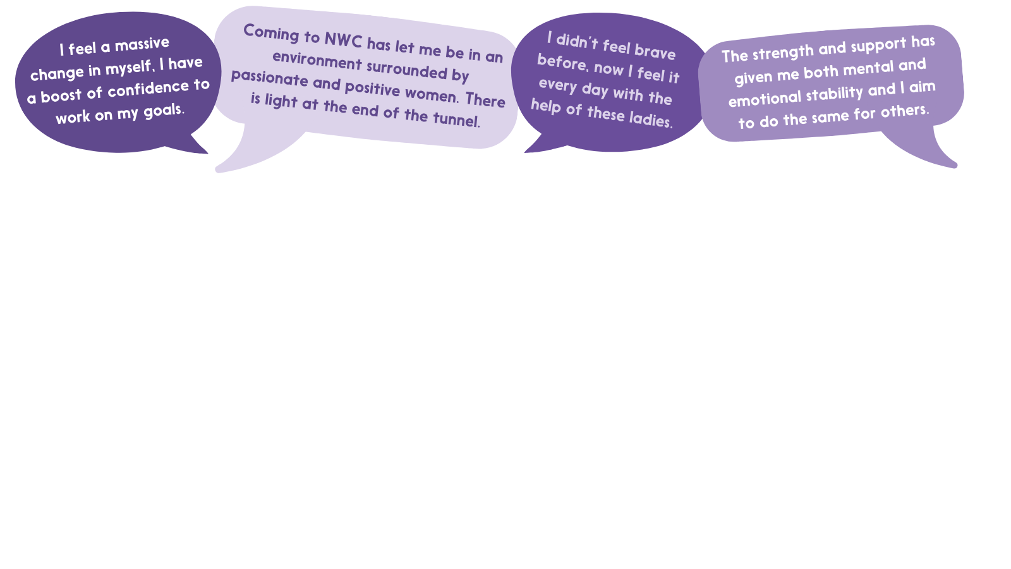*Service users say…**

**Working at Nottingham Women’s Centre**

We offer a **generous amount of leave**, opportunities for**flexible working, personal development**and a**supportive working environment**. In our latest annual staff survey**100% of staff said they were proud to be part of Nottingham Women’s Centre** and would recommend us as a great place to work. Staff say:

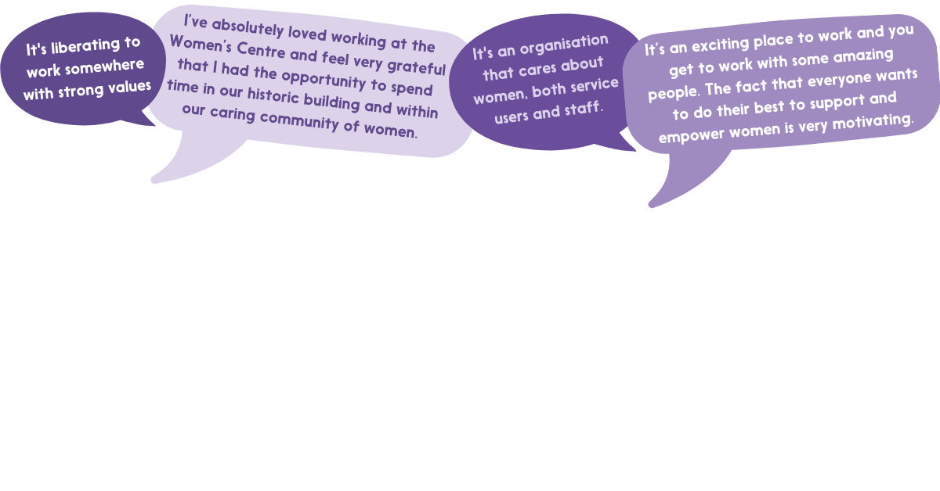

|  |  |
| --- | --- |
| Job Description | |
| Post Title | Receptionist/Administrator |
| Responsible to | Senior Administrator |
| Location | Nottingham Women’s Centre |
| Hours | 22 hours per week  The centre is open 9am-8pm Mon, Tue, Wed, 9-5 Thur and Friday and 4 hours on the occasional Saturday. Your hours will be divided between these hours but will cover up to 2 x 8pm finishes. The hours would be spread out over 4 days. |
| Salary | £24,862 pro rata |
| Contract | Fixed Term 31 March 2025 |
| General Description | |
| This role is responsible for coordinating reception and being the first point of contact for enquiries, welcoming women and visitors, to the Centre and on the telephone. The post holder will undertake a range of administrative and reception duties in order to support the work of the Nottingham Women’s Centre. | |
| Key Tasks and Responsibilities | |
| * Provide administrative support to NWC services * To undertake general office duties including photocopying, scanning, shredding, filing etc. * Take responsibility for recording data and maintaining information and related filing systems * Staff the reception, welcoming all clients and visitors * Respond appropriately to all calls and enquiries by telephone, email and letter. This is not an advice role. * Provide prompt and appropriate referrals to services within the Centre and signpost to external agencies * Be prepared to step out from behind the desk to offer additional support to a client in crisis until another staff member arrives * Provide excellent customer service at all times whilst being sensitive to the needs of vulnerable clients * Possibly induct and supervise volunteers. * Take responsibility for general housekeeping duties such as ensuring reception area and welcome space is tidy and fit for purpose, stationary is replenished and notice boards are updated. * Be responsible for cash handing and issuing receipts. * Take responsibility for opening and closing reception as appropriate. * Provide additional reception cover from time to time as needed, for example to cover periods of leave or sickness (if your other commitments allow). * Assist in the organisation and co-ordination of key events (E.g. open days, celebrations, International Women’s Day) * Ensure that all work is carried in accordance with relevant legislation and Nottingham Women’s Centre policies and procedures, including the Centre’s Equal Opportunities policy and Health and Safety Policy. * Participate in training and development as required. * Act as an effective team member and attend and contribute to staff meetings.   Carry out other duties as directed by Senior Managers. | |
| Notes | |
| As part of our anti-racism work ethnic minority candidates that meet the minimum criteria (marked with a *) will be guaranteed an interview. This positive action is being taken to further diversify our team.  Due to the nature and sensitivity of the project’s client group, the post holder must be a self-identifying woman.  We offer a generous amount of leave, opportunities for flexible working, personal development and a supportive working environment that includes access to an employee assistance programme. | |

|  |  |  |  |  |  |
| --- | --- | --- | --- | --- | --- |
| Person Specification | | | | | |
|  | Essential | Desirable | Assessed by | | |
| Application form | Interview | Test |
| Qualifications | GCSE pass at A-C standard (or equivalent) for English and Maths or the ability to work to this level | Attendance of appropriate training and courses. | 🗸 |  | 🗸 |
| Experience | Experience in a demanding reception or administration environment. | Experience of supporting volunteers | 🗸 | 🗸 |  |
| Experience of dealing with people involved in sensitive and confidential situations. | Experience of offering information and guidance. | 🗸 | 🗸 |  |
| Skills and Knowledge | Proficient in MS Office applications in general – including spreadsheets and databases for record keeping, Word and Publisher. |  | 🗸 | 🗸 | 🗸 |
| Effective organisational skills with ability to prioritise own workload and meet deadlines. |  | 🗸 | 🗸 |  |
| Verbal and written communication skills and a high standard of customer service |  | 🗸 | 🗸 | 🗸 |
| Ability to work both in a team and independently effectively. |  | 🗸 | 🗸 |  |
| Ability to work flexibly in order to meet the varying demands of the job. |  | 🗸 | 🗸 |  |
| Ability to demonstrate a non-judgmental attitude and work to the values of the Women’s Centre. |  | 🗸 | 🗸 |  |
| Practical knowledge of customer service and the actions needed to deliver services. |  | 🗸 | 🗸 |  |
| Awareness of equality and diversity, particularly women’s issues and vulnerable adults |  | 🗸 | 🗸 |  |
| Knowledge of local support services and interventions |  | 🗸 | 🗸 |  |
| Other | Willing and able to work outside normal office hours as required |  | 🗸 | 🗸 |  |