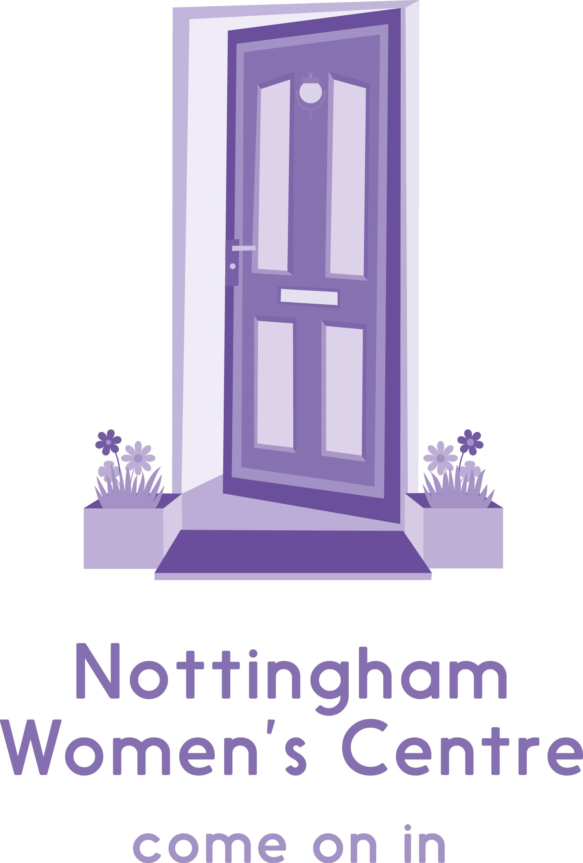

Information about our recruitment process for applicants

Applying for a job at Nottingham Women’s Centre

We aim to ensure that every applicant is treated fairly. This means that when we shortlist, we remove all personal information from your application form – meaning that we are not able to consider previous applications or any personal knowledge that we have about you, only the information that you provide us with in your application form.

This means that completing your application form correctly is very important.

Completing your application form

A few tips to help you to complete your application form correctly:

- Make sure your form is filled in clearly – ideally use a computer as this makes the form more legible and will allow you to fit more in.
- Include information about paid work and any volunteering that you have done. If there are gaps in your work history, explain why so that we understand this.
- Refer to the person specification when completing the section on ‘Experience / suitability / interests’. The person specification lists the criteria that we are looking for and it is this that we will shortlist against.
- Demonstrate how you can fulfil each of the criteria on the person specification, drawing on your experience in other jobs, volunteer work or life experiences. Don’t just say that you can do something – provide specific examples about how you’ve done this in the past or what you know about the subject.
- You are allowed to attach one extra sheet to explain your experience, suitability and interests. We will disregard any additional sheets beyond this so do try to be concise.
- Please give as your referees your current and most recent employers where possible, or if not, someone who knows you in a professional context, rather than a personal referee.
- Make sure you double check your application for mistakes before sending it to us.

Make sure you submit your completed form before the deadline as late applications are unlikely to be accepted. Send it to jobs@nottinghamwomenscentre.com

After you apply

After the closing date, we shortlist the application forms by reading them through to see which applicants have best demonstrated that they can meet the skills and experience that we require for the job. The best applicants will be invited for an interview, usually within 2 weeks of the closing date. Please note that we do not give feedback on unsuccessful applications at this stage.

Before the interview, we would advise that you find out more about our organisation and about the job that you are applying for. You’ll usually find plenty of information on our website but if you have any specific questions, feel free to give us a ring and ask!

The interview panel will normally be made up of three people who have some wider interest in the job, including the immediate manager. Panel members will ask each candidate the same set of questions, with the aim of discovering how much each candidate meets the requirements for the job. Panel members will take notes so that scores can be agreed afterward and so that the reasons for their decisions are clear and consistent. You will also have the opportunity during the interview to ask the panel any questions that you might have about working for us.

In some cases, we will also ask shortlisted candidates to complete a test before the interview or prepare a presentation beforehand. If this is the case, you will be informed of this when you are invited for interview.

After the interview, usually before the end of the day, we will ring you to let you know whether you have been successful. If you are unsuccessful and would like feedback on your interview, we will be happy to give it at this point.

