  **Winter Info 2024/25**

**Support services in Nottingham/Notts this Winter (version 3)**

**Latest updated version is available**[**here**](https://drive.google.com/drive/folders/1oGSXcpGXZepfjIMKBhoycaxCeDslrH_a?usp=sharing)

**And Street Support Nottingham**[**https://streetsupport.net/nottingham/**](https://streetsupport.net/nottingham/)

**The Wellbeing Hub**

****Drug and alcohol support in Nottingham City

73 Hounds Gate, Nottingham NG1 6BB

**Telephone: 0800 0285598**

****[**https://www.nottinghamrecoverynetwork.com/**](https://www.nottinghamrecoverynetwork.com/) **E-mail** [**info@nottinghamrecoverynetwork.com**](mailto:info@nottinghamrecoverynetwork.com)



**The Wellbeing Hub makes it easier for people in Nottingham to get the help and support they need - for mental health, drugs, alcohol, housing and more.**

**With Christmas coming up…. It is important to remember…**

**Collection days may change!**

It is important you are checking with your pharmacist when you are due to collect prescription due to Pharmacy closure

**Risk of Overdose**

People may overindulge over the festive period,be aware of overdose if you choose to drink or use more than usual**. Be Aware!** You may be given additional unsupervised days of medication due to pharmacy closure. Please make sure you keep your additional doses safe and take as prescribed to ensure you have medication throughout the holiday period. Ask your Key Worker for a lock box. Please remember if your medication is taken by somebody who it is not prescribed for, they are at very high risk of overdose. **IF THIS HAPPENS RING 999 IMMEDIATELY**.

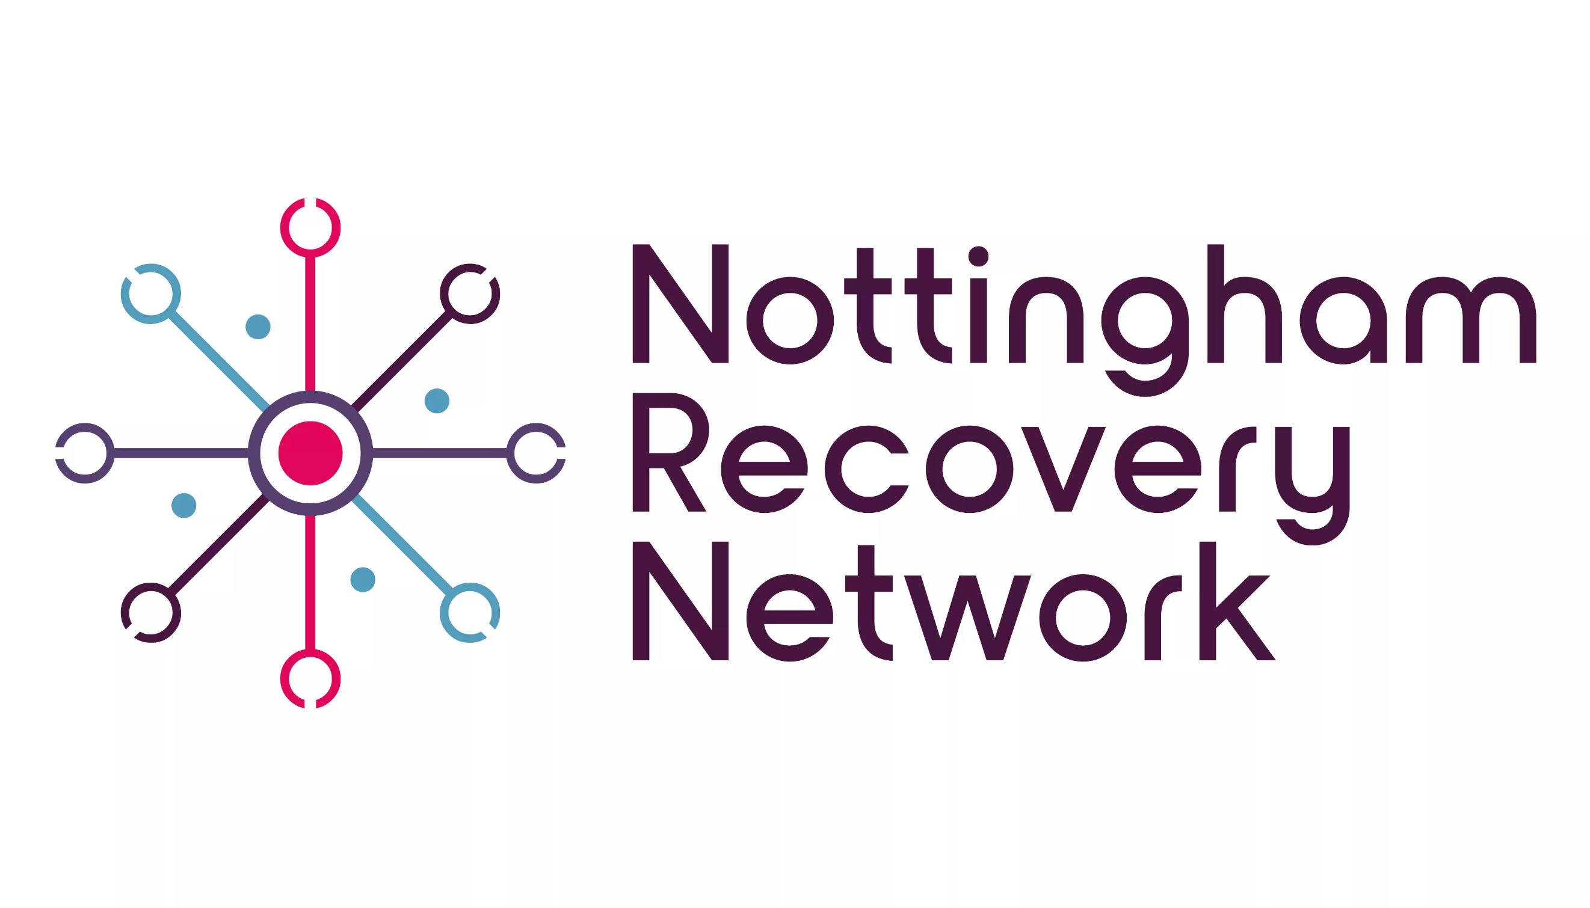**Have you got supply of Naloxone?**

Naloxone can be given here at Nottingham Recovery Network and at The Health Shop. This could save your life or the life of a friend.

**NRN Academy Group timetable**

The community rehab recovery safe space area at NRN will also be open 9.30-4.30 weekdays and 11-12.30 Saturdays.

Anyone attending will need to have had a referral from their NRN keyworker, apart from attending SMART recovery.

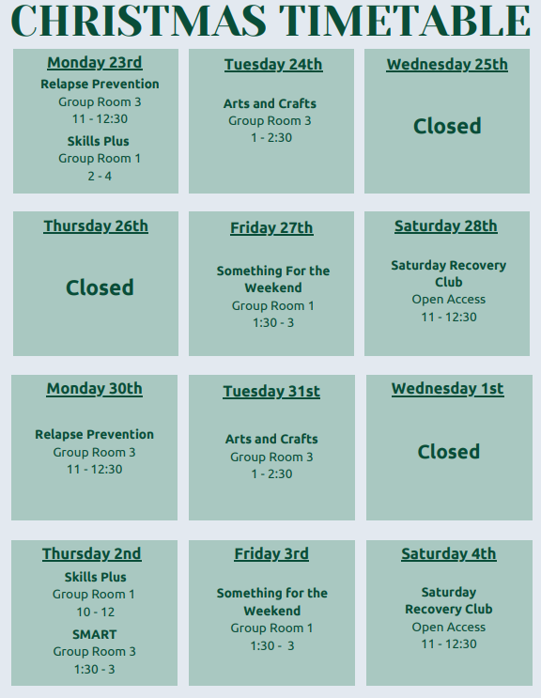

**NRN Harm Reduction Service/Broad Street Needle Exchange**

**The Health Shop **

**Specialist needle exchange, harm reduction and sexual health service**

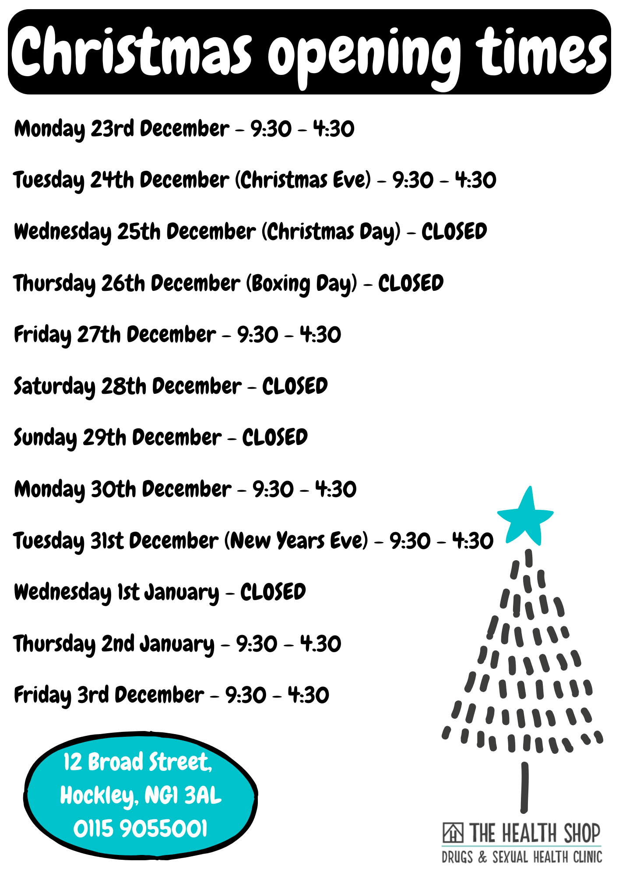

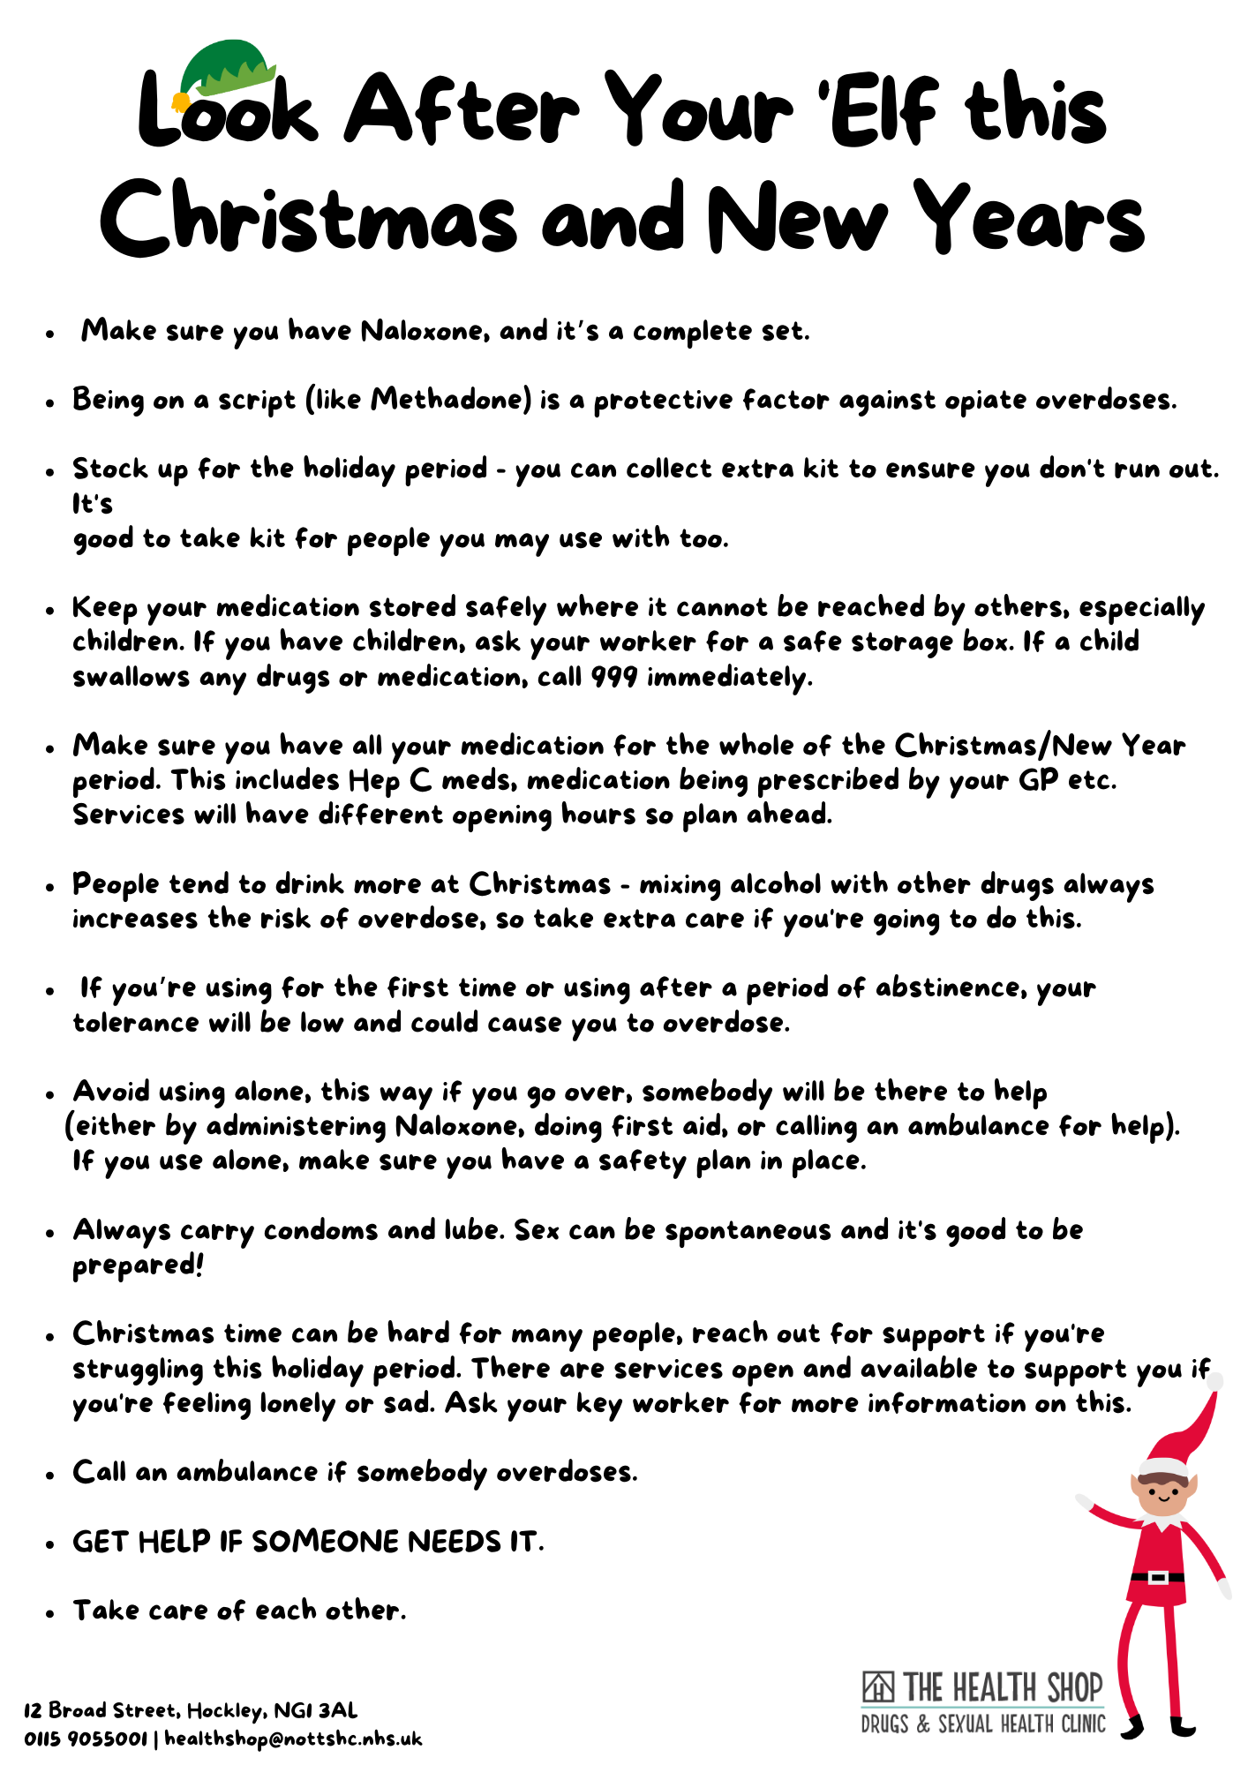



**Sexual Health Services Nottingham and Notts**

To book an appointment please call us on **0300 131 7010**

Contact centre opening hours:

Monday & Thursday: 8am-7pm

Tuesday & Wednesday: 8:30am-7pm

Friday: 8am-6pm

Saturday: 10am-2pm

The service will be closed on:

Wednesday 25th December 2024

Thursday 26th December 2024

Wednesday 1st January 2025

We offer walk in sessions for under 25’s Monday-Thursday 2pm-6pm at Victoria Health Centre,

Glasshouse Street, Nottingham, NG1 3LW

For more information on the services we offer please visit

[**www.nuh.nhs.uk/sexual-health-services**](http://www.nuh.nhs.uk/sexual-health-services)

**Al-Hurraya **

Help people in Black, Asian, Minority Ethnic and Refugee (BAMER) communities to overcome multiple adversities, including addiction and crime, to fulfil their full potential.

TEL: 0115 7869206 – 07368579469.  |  [info@al-hurraya.org](mailto:info@al-hurraya.org)

**Street Outreach T****eam**

**For those facing rough sleeping or if you are concerned about someone**

**Available every day, 24 hours on 0800 066 5356.**

**Option 1 for City and Option 2 for County**

[**https://thestreetlink.org.uk/**](https://thestreetlink.org.uk/)

**--------------------------------------------------------**

** CGL The Place **

**Young People, Young Adult & Family Service for Drugs and Alcohol**

Offer a range of support services primarily for young people up to the age of 25 around drugs and alcohol.

We also offer specialist support in a confidential and safe space for children and young people impacted by somebody else’s substance use (sometimes referred to as hidden harm).

[www.changegrowlive.org/the-place-nottingham/info](http://www.changegrowlive.org/the-place-nottingham/info) **Email:** [theplace@cgl.org.uk](mailto:theplace@cgl.org.uk)

T: 0115 948 4314

Our opening times over Christmas are:

December 23rd – 9-5

24th – 9-12

25th closed

26th closed

27th 9-5

30th – 9-5

31st – 9-12

January 1st – closed.



Improving the lives of people facing Severe and Multiple Disadvantage (SMD) in Nottingham City through  
system change

Freephone - 0800 055 6191

Office Number - 0115 850 4128

Email [changingfutures.refs@frameworkha.org](mailto:changingfutures.refs@frameworkha.org)

Monday 23rd December: 9am – 5pm

Tuesday 24th December: 9am – 5pm

Wednesday 25th December: Closed

Thursday 26th December: Closed

Friday 27th December: 9am – 4.00pm

Monday 30th December: 9am – 5pm

Tuesday 31st December: 9am – 4pm

Wednesday 1st January: Closed

Thursday 2nd January: 9am – 5pm

Friday 3rd January: 9am – 5pm

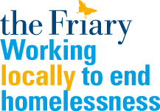----------------------------------------------------------

**The Friary**

46 Musters Road, West Bridgford, NG2 7PR

**Mon, Wed, Fri** – 8am – 12 noon (open to all)

**Tue, Thu** – 8am – 11.30am (rough sleepers only)

Normal hours over the Christmas period, apart from

Christmas Day - 1pm (tickets only)



Emmanuel House Support Centre  
53-61 Goose Gate  
Nottingham NG1 1FE

**Telephone** 0115 9507140

Support: [support@emmanuelhouse.org.uk](mailto:support@emmanuelhouse.org.uk)

|  |  |  |  |  |
| --- | --- | --- | --- | --- |
| ***OFFICE HOURS*** | | | | |
| ***Monday 23rd Dec*** | ***Tuesday 24th Dec*** | ***Wednesday 25th Dec*** | ***Thursday 26th Dec*** | ***Friday 27th Dec*** |
| 9am-5pm | 9am-3pm | 10.30am-2.30pm | 10.30am-2.30pm | 9am-2.30pm |
| ***Monday 30th Dec*** | ***Tuesday 31st Dec*** | ***Wednesday 1st Jan*** | ***Thursday 2nd Jan*** | ***Friday 3rd Jan*** |
| 9am-2.30pm | 9am-2.30pm | 11am-2pm | 9am-5pm | 9am-5pm |

|  |  |  |  |  |
| --- | --- | --- | --- | --- |
| ***DROP-IN HOURS*** | | | | |
| ***Monday 23rd Dec*** | ***Tuesday 24th Dec*** | ***Wednesday 25th Dec*** | ***Thursday 26th Dec*** | ***Friday 27th Dec*** |
| 9.30am-midday  1pm-2pm | 9.30am-midday  1pm-2pm | 11am-2pm | 11am-2pm | 9.30am-midday  1pm-2pm |
| ***Monday 30t Dec*** | ***Tuesday 31st Dec*** | ***Wednesday 1st Jan*** | ***Thursday 2nd Jan*** | ***Friday 3rd Jan*** |
| 9.30am-midday  1pm-2pm | 9.30am-midday  1pm-2pm | 11am-2pm | 9.30am-midday  1pm-2pm | 9.30am-midday  1pm-2pm |

Emmanuel House will be running open access drop-in sessions throughout the festive period offering a warm space, food, showers, clothing, laundry and support for homeless and vulnerable people.

* On Christmas Day, we’ll serve a Christmas dinner with all the trimmings, including presents, crackers and board games, and we’ll open for basic services and support.
* Our Winter Shelter will be open every night over Christmas, providing short-term emergency accommodation. Please send referrals to [wintershelterEH@emmanuelhouse.org.uk](mailto:wintershelterEH@emmanuelhouse.org.uk)
* We are hugely grateful to all those who donate to us but we do please ask people to bring all food and clothes donations to the Support Centre before Weds 18 Dec.



[**www.pow-advice.org.uk**](http://www.pow-advice.org.uk)

**Monday 23rd December**

1-4pm Drop In

7-9pm Outreach

**Friday 27th December**

7-10pm Outreach

**Monday 30th December**

1-4pm Drop In

7-9pm Outreach

**Thursday 2nd January**

1-5pm Drop In

**Friday 3rd January**

7-10pm Outreach



**Warm Space for Women**

Nottingham Women's Centre (NWC) is offering a warm, safe, and comfortable space for women to access right in Nottingham’s City Centre. The Warm Space will be open for all women from Monday – Friday, 9am – 5pm, at Nottingham Women’s Centre’s 30 Chaucer Street home and hub. **NOTE: NWC is open up to 4pm on 24th December, and then re-opens on Thursday 2nd January.**

There are hot drinks, books from the Library, and many activities and services that run from the Centre. The Centre’s hot shower and laundry facilities are also available to women. And a bookable, fully equipped kitchen provides a resource for women to cook meals for themselves and their families.

More details online here: <https://www.nottinghamwomenscentre.com/warm-space-for-women-launches-at-nwc/>

**PLEASE NOTE: Nottingham Women’s Centre’s building and phone line closes at 4pm on Tuesday 24th December & re-opens on Thursday 2nd January 2025 at 9am.**

**More info on closure dates and support numbers here:** **nwcentre.com/WINTER**



**Nottingham Muslim Women’s Network – Christmas Opening Times**  
We’re here to support you throughout the festive season!

**Opening Hours:**

* Monday to Friday: 9 AM - 4 PM

**Holiday Closures:**

* Closed on 25th & 26th December 2024
* Closed on 1st January 2025

For more information, please visit our website or contact us directly.

<https://nottinghammuslimwomensnetwork.co.uk/>

email: [enquiries@nmwn.co.uk](mailto:enquiries@nmwn.co.uk)

phone: 01158 372627 / 07826 464722

**Gambling Support**

Would you recognise the signs of gambling harm?

Gambling can affect physical and mental health, damage relationships and leave people feeling lonely and isolated. It can also cause problems with employment, education, housing and lead to serious debt.

Gambling is not just limited to casino-style games and to sports betting, there are many other forms of gambling including scratch cards, bingo, lotteries, and in-console gaming.

Gambling-related harm is under-recognised and often hidden, but there are many signs which may help you recognise if gambling is causing harm. If you notice that you, or someone you know, is feeling stressed, anxious or isolated, or are thinking about gambling a lot of the time, it could be a sign of gambling harm.

 To learn more, and to find out about free advice and treatment services available in Nottingham, visit: [www.asklion.co.uk/gamblingsupport](https://www.asklion.co.uk/gamblingsupport)

To learn more, and to find out about free advice and treatment services available in Nottingham, visit: [www.asklion.co.uk/gamblingsupport](https://www.asklion.co.uk/gamblingsupport)



**Double Impact’s ‘TimeOut’ Gambling Recovery Service is a new service for Nottingham city.**

Here at TimeOut, we are passionate about starting the conversation, reducing the stigma associated with a gambling harms and empowering individuals to recover.

We offer:

* 1-1 holistic support, screening & recovery planning
* Guided peer-led support groups
* Recovery Planning based on your goals, your strengths and assets
* Helping you access wider/ specialist support
* Specialist cultural support (through partner Al-Hurraya)

Get in touch through our website: <https://www.doubleimpact.org.uk/time-out-gambling-project>

Or email us at: [timeout@doubleimpact.org.uk](mailto:timeout@doubleimpact.org.uk)

Or phone us on 07706 732649

**Domestic and Sexual Violen****ce**

**Domestic Violen****ce Helpline**

**Run by Juno Women’s Aid**

Open 24 Hours. Tel: 0808 800 0340

(0808 800 0341 with text phone)

**Notts Sexual Violence Support Service (Notts SVSS)**

[www.nottssvss.org.uk](http://www.nottssvss.org.uk/)

**0115 941 0440**

**Nottinghamshire Sexual Violence Support Services helpline provides access to sexual violence and abuse services for women and men in Nottingham and Notts.**

**Helpline be closed on**

**• Christmas Day**

**• Boxing Day**

**• New Years Day**

**Open as usual at all other times**

**10am to 1pm & 4.30pm to 7.30pm (Mon – Fri)**

**10am to 1pm (Sat morning)**

**Equation’s Men’s Service:**

0115 960 5556

A confidential answerphone runs 24/7

[helpline@equation.org.uk](mailto:helpline@equation.org.uk)

[www.equation.org.uk](https://eur02.safelinks.protection.outlook.com/?url=http%3A%2F%2Fwww.equation.org.uk%2F&data=04%7C01%7Cbennjoseph%40equation.org.uk%7C8ba134f42f2b4653ed2908d9be1ce6c6%7C8302955564354427af10f43b5b59a0b1%7C1%7C0%7C637749854049250949%7CUnknown%7CTWFpbGZsb3d8eyJWIjoiMC4wLjAwMDAiLCJQIjoiV2luMzIiLCJBTiI6Ik1haWwiLCJXVCI6Mn0%3D%7C3000&sdata=V3MG9wIne9%2Fr%2Ftr5CKbJakjlR1xy9cc9cTk44Fex2%2F0%3D&reserved=0)

Helpline Mon-Fri 09:30-16:30 (Closed on the Bank Holidays)

IDVA Service Mon-Fri 09:00-17:00 (Closed Bank Holidays)

**Children Sexual Violence and Abuse Support Service**

[**www.imara.org.uk**](http://www.imara.org.uk)

**Hel****plines and websites**

**Samaritans – 08457 90 90 90**

**------------------------------------------**



**Mental health support**

**To find information, advice and how to access local support for anything to do with mental health, visit the new NottAlone website.**

**It includes information and advice on many different topics - whether you are looking for yourself, for a family member or friend, or as a professional working with someone who needs support.**

**You may know NottAlone as a mental health website for children and young people in Nottingham and Nottinghamshire. NottAlone has now been expanded and relaunched with support for everyone, of all ages.**

**Visit** [**www.nottalone.org.uk**](http://www.nottalone.org.uk) **to find out more.**

**Nottinghamshire CRISIS Sanctuaries-**

**We are a free service and here to offer support, information, and guidance to anyone 18 years or older in or nearing a mental health crisis. Our team is ready to listen and waiting to hear from you on**[**0330 822 4100**](tel:03308224100)**Our open hours are from 4pm till 11pm every day of the year seven nights a week.**

**Sane: Phone 0300 304 7000 6pm – 11pm. Online:** [**www.sane.org.uk**](http://www.sane.org.uk)

**SHOUT – 24/7 text service** – 85258 with immediate need of support with mental health

**NCHA SMaRT Mental Health Helpline: For more information** contact:  
08005610072  
Or text 0750 662 8693 and we will call you back.

**Self harm: Support via email:** [**www.nshn.co.uk/contact.html**](http://www.nshn.co.uk/contact.html)

**RETHINK:** [**www.rethink.org/**](http://www.rethink.org/)living with mental illness / coping in a crisis Call 0300 5000 927 Monday to Friday, 10am-2pm

**CALM (campaign against living miserably)** 5pm – Midnight everyday. Use Webchat or the Helpline 0800 585858

**MIND:** Support and information relating to all mental health conditions. Phone 0115 934 8445. Online: [www.mind.org.uk/help/crisis](http://www.mind.org.uk/help/crisis) or locally

**Mansfield and Ashfield.** [**http://centralnottsmind.com/**](http://centralnottsmind.com/)

**Bassetlaw** [**http://www.bassetlawmind.org.uk/**](http://www.bassetlawmind.org.uk/)

**Every Mind Matters Website** by NHS England that offers education, and advice on mental and physical health, with links to useful mobile apps and websites. [www.nhs.uk/oneyou/every-mind-matters/](http://www.nhs.uk/oneyou/every-mind-matters/)

**FRANK – 24 hr national drugs helpline.**

**Tel: 0300 123 6600** [**www.talktofrank.com**](http://www.talktofrank.com)

**Soup Runs, free food, and advice.**

**(see also warm spaces list)**

**Bridgeway Methodist Church Sunday Supper.** Sundays from 5pm cater for up to 50 people.

Queens walk community café also do food parcels and have surplus food out daily for anyone to collect if needed - Home | Queens Walk Community Association (qwca.co.uk)

**Tracy’s** are doing hot food for rough sleepers on Christmas and Boxing Day

We are running our usual Social Cafe on Tuesday 24th December but then we are closed until Thursday 2nd January when we open again as usual.

**Hope – East and West Nottingham Foodbanks. Here** <https://eastwestnottingham.foodbank.org.uk/locations/> are details of the opening hours for all of our foodbanks over the festive period. They ask that everyone who comes to the foodbank for emergency food has a valid foodbank voucher.

**Normal Food support weekly rota – NOTE: may be different during the Christmas and New Year period. – See above**

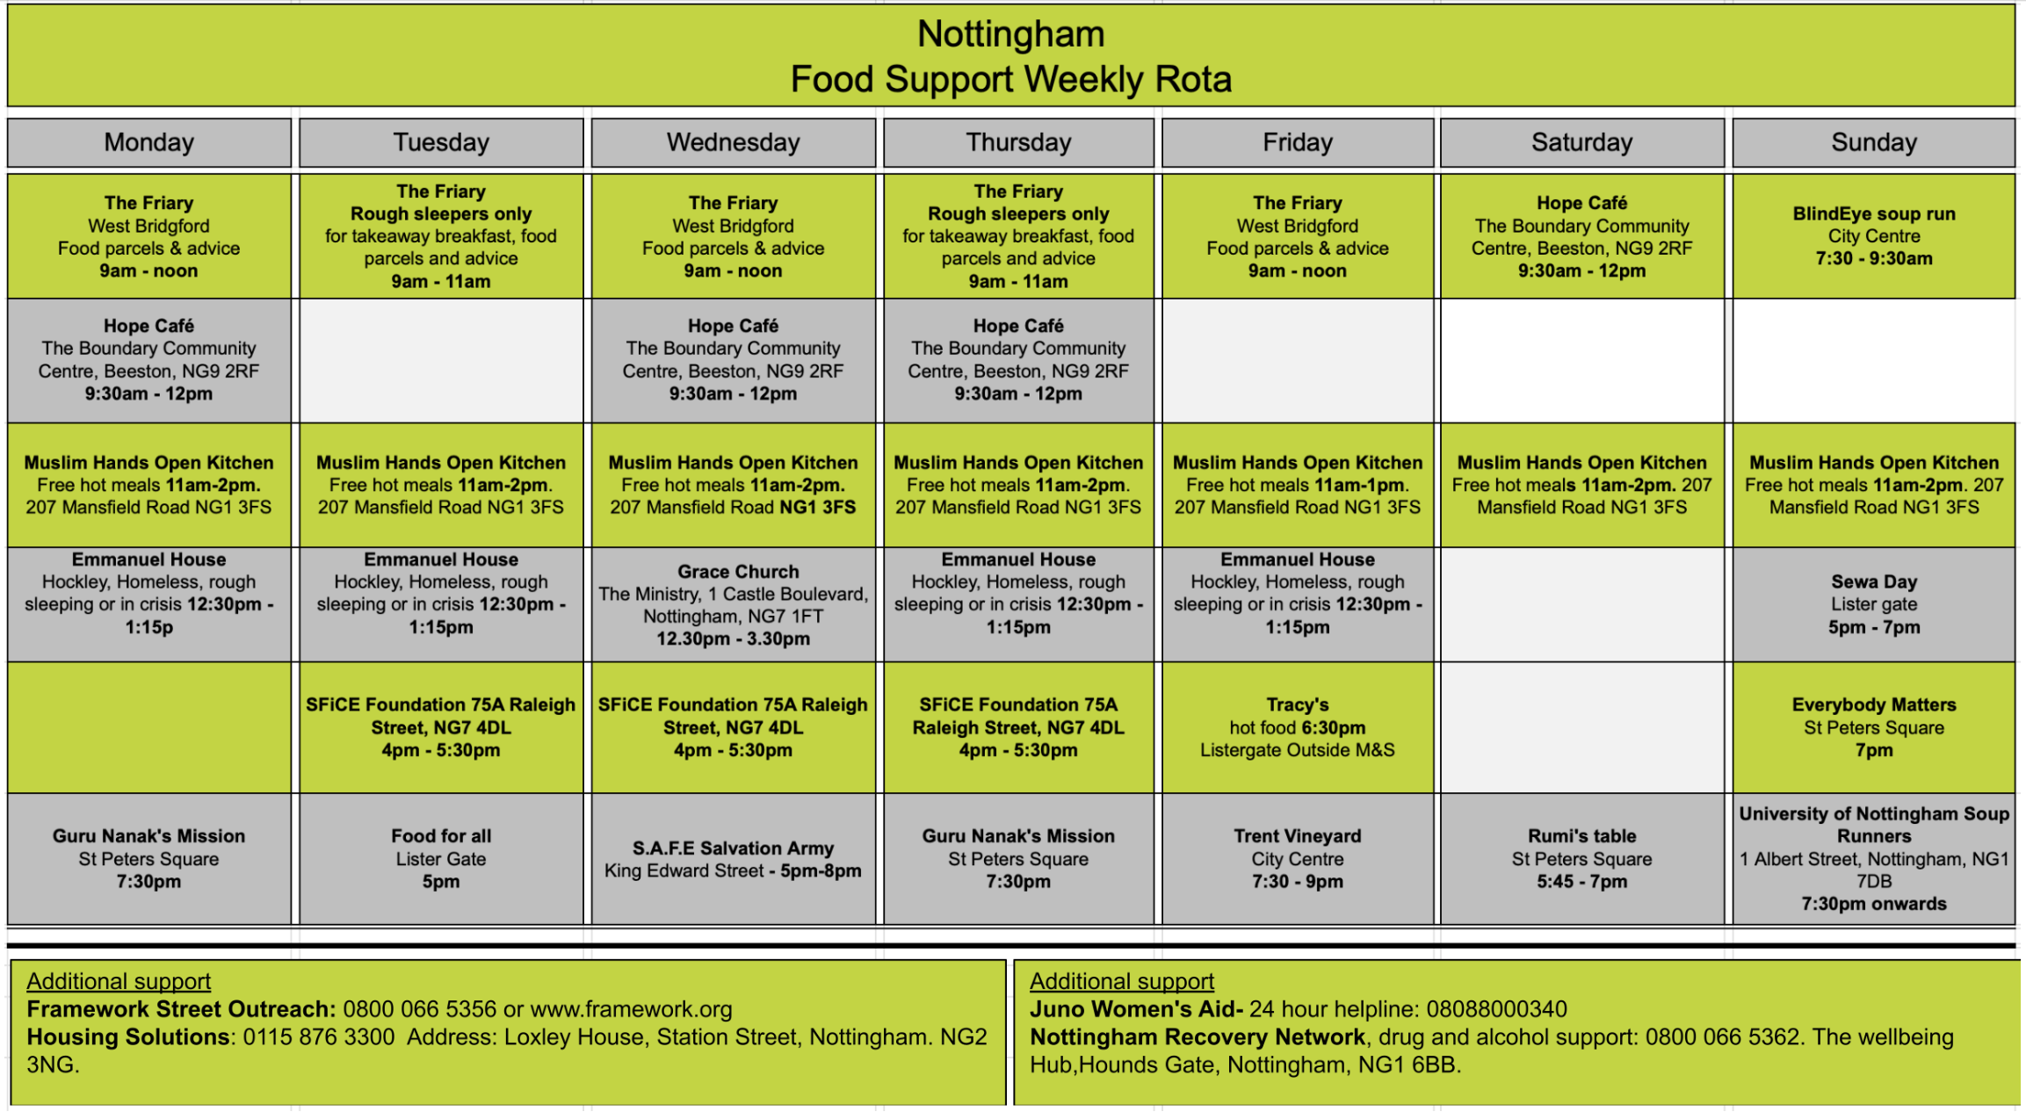



Many residents may be struggling this winter to deal with increasing household bills, as the cost-of-living crisis continues, and the days become colder.

ASKLiON and [**Nottingham Energy Patnership**](https://www.nottenergy.com/) have come together to list partners, community and voluntary organisations that have opened up buildings as warm spaces for any resident to freely access and stay warm during their opening hours.

These welcoming spaces at the heart of our communities, offer somewhere for residents to go to keep warm, meet other people, or even an alternative place to work other than their own home. Some of the spaces may also offer refreshments and activities, as well as information on how to reduce bills and access support.

Don't forget to [**visit the dedicated ASKLiON Money Advice page for support on Benefits, Energy, Debt, Government Schemes, Food parcels, Food banks, Reducing bills and more.**](https://www.asklion.co.uk/kb5/nottingham/directory/site.page?id=RPMRNRqTO6o)

**Details can be found here:**

[ASKLiON | Ask Lion - Nottingham City Directory](https://www.asklion.co.uk/kb5/nottingham/directory/advice.page?id=iR3SMqrXk68)

This list is being updated regularly – It can be displayed on a map or printed.

**Current list is below**

**NOTTINGHAM CITY WARM HUBS**

**NOTTINGHAM LIBRARIES – NOT INCLUDED – See section below**

|  |  |  |  |  |
| --- | --- | --- | --- | --- |
| AREA | ORGANISATION AND VENUE | DAYS AND TIMES | ACTIVITY/OFFER | CONTACT DETAILS |
| Basford | Renew Community Café  Basford Road Baptist Church  Basford Road, NG6 0JL | Wednesday  Morning, 11am - 1pm | A range of Hot and Cold Drinks, Cakes & Pastries available for a small donation. We also have board games and craft activities to take part in. We aim to make this space somewhere for you to be comfortable where it's ok not to be ok. | Nicola Darlington 07790276892  enquiries@basfordroadbaptist.org.uk |
| Bestwood | Arnold Rd Evangelical Church  Arnold Road  NG5 5HN | Tuesdays 10am- 11:30am | Coffee morning | pastor@arnoldroad.org 0115 920 1788 |
| Bilborough | Beechdale Community Centre Ambergate Road, NG8 3GD | Monday to Friday 6pm – 8pm | Warm space | 0115 915 0285  07889662637 |
| Bilborough | Beechdale Community Centre Ambergate Road NG8 3GD | Monday to Friday 10am-4pm | Games, Hot Meals, Hot drinks, Advice, Support, Food bank, various group activities | 01159150285  07889662637 |
| Sherwood | #Well Café, The Pillar Box 566 Mansfield Road NG5 2FS | 2nd & 4th Thursday of the month 3pm – 5pm | Our cafes are designed to connect individuals to like-minded people in the community, sharing well-being tips, interests and skills. There is offer of tea, coffee and biscuits. | katie.hale@nottinghamshiremind.org.uk |

**NORTH LOCALITY**

**CENTRAL LOCALITY**

|  |  |  |  |  |
| --- | --- | --- | --- | --- |
| AREA | ORGANISATION AND VENUE | DAYS AND TIMES | ACTIVITY/OFFER | CONTACT DETAILS |
| Aspley | St Martha’s Church  137-139 Frinton Road NG8 6GR | Wednesdays 10am- 12pm | Community Café | 0115 9298899  Info@wearewoven.church |
| Aspley | St. Marthas Vicarage  135 Frinton Road NG8 6GR | Wednesdays 10am- 12pm | Free community cafe | 0115 929 8899  Info@wearewoven.church |
| City Centre | Emmanuel House Support Centre 53-61 Goosegate, NG1 1FE | Monday, Tuesday,  Thursday and Friday, 12.30pm – 1.15pm. | Food and company. Community members can use the centre as a warm safe place to help reduce fuel bills at home.    Charging £2 for meal or £10 for 10 meals when ordered in advance. | 0115 950 7140  E-mail  admin@emmanuelhouse.org.uk |
| City Centre | Grace Church  1 Castle Boulevard NG7 1FT | Tuesday 10am- 11:30 | Family Foundations sessions - free play, support parcels for young families (including food parcels if needed), befriending and signposting | hello@gracechurchnottingham.org |
| City Centre | #Well Café, National Ice Centre,  Bolero Square NG1 1LA | Mondays 10:45am – 12:30pm | Our cafes are designed to connect individuals to like-minded people in the community, sharing well-being tips, interests and skills | katie.hale@nottinghamshiremind.org.uk |
| Hyson Green | Salaam Shalom Kitchen; The  Bridge Centre, 49a, Gregory  Boulevard  NG7 5JA | Every Wednesday, 5pm - 6.30pm | Warm space and hot meals ; also take away meals and groceries | 07729288460  info@salaamshalomkitchen.co.uk |
| Hyson Green | SFiCE House; 75a, Raleigh Street Arboretum, NG7 4DL | Tuesdays,  Wednesdays &  Thursdays, 4pm5.30pm | Hot meals for the homeless and communities in need. Free, or small donation if one can afford it | 0115 978 9256 07941378265 info@sfice.org |
| Wollaton | Wollaton Park Community Coffee Shop, Harrow Road NG8 1FG | Thursdays 8:45am- 11:45am | A warm safe place to help reduce fuel bills at home. We run a coffee shop and offer subsidised hot drinks and food. | 0115 928 8860  wpcommunitycentre@googlemail.com |
| Wollaton West | St Thomas More's Church Hall 2 Glenwood Avenue NG8 2GA | Fridays, 12.30pm - 2pm | Food and company. Community members can use the centre as a warm safe place to help reduce fuel bills at home. | 0115 929 5907  st.thomasmore.wollaton@outlook.com |
| **Nottingham Women's Centre added to the list this year as a dedicated warm space.** Nottingham Women's Centre is offering a warm, safe, and comfortable space for women to access right in Nottingham’s City Centre. The Warm Space will be open for all women from Monday – Friday, 9am – 5pm, at Nottingham Women’s Centre’s 30 Chaucer Street home and hub. **NOTE: Up to 4pm on 24th December and then re-opens on Thursday 2nd January**  There are hot drinks, books from our Library, and many activities and services that run from the Centre. The Centre’s hot shower and laundry facilities are also available to women. And a bookable, fully equipped kitchen provides a resource for women to cook meals for themselves and their families.  More details online here: <https://www.nottinghamwomenscentre.com/warm-space-for-women-launches-at-nwc/> | | | | |

**SOUTH LOCALITY**

|  |  |  |  |  |
| --- | --- | --- | --- | --- |
| AREA | ORGANISATION AND VENUE | DAYS AND TIMES | ACTIVITY/OFFER | CONTACT DETAILS |
| Clifton | Holy Trinity with St Francis Church Farnborough Road, NG11 9DG | Wednesdays 9 - 11am | Drop-In Cafe with tea, coffee, toast and biscuits. Have a chat and make new friends. All free.    DROP IN CAFÉ with prayer time at 11am (all welcome, no pressure to take part in prayers) | 074591382105 juleshilton@outlook.com |
| Dales | Oliver Hind Youth Club  Edale Road, NG2 4HT    WILL CALL ME BACK TO CONFIRM  IF WILL BE ONGOING | Mondays, Tuesdays,  Thursdays: 12 - 3pm    Wednesdays,  Fridays: 10am - 3pm | Come relax, chat, or simply take a break from your day. You can sip on tea or coffee, savour fresh fruit, and perhaps indulge in a biscuit or two. Plus, feel free to make the most of our facilities - enjoy a game of table tennis, pool air hockey, or table football. | 0115 837 2021 |
| Sneinton | Sneinton Hermitage Community  Centre  51 Sneinton Boulevard NG2 4FD | Tuesday 10-1pm  Warm Hub  Thursday 11-1.30pm  Noor Project | Warm Hub is a drop in session run by social prescribers offering advice, health & finance etc. various activities i.e board games/quizzes/card games. refreshments available  Noor Project offer a hot meal and pudding, social interaction with other people  Yoga and various other arts/crafts activities | sneintonhermitagecc@gmail.com 07974394042 |
| St Ann’s | Chayah Development Project 26 Robin Hood Chase NG3 4EZ | Wednesdays, 9am -  2.30pm from  November 2024 | Community members can use the centre as a warm safe place to help reduce fuel bills at home.  Hot meals for £1.00, free hot drinks | Hya@chayahgroup.co.uk |
| St Ann’s | Open Kitchen  207 Mansfield Road NG1 3FS | Mondays to  Thursdays 11am- | People are able to pop into the café without booking | Muslim Hands 01159117222 |
|  |  | 2pm Fridays 11am-  1pm |  | mail@muslimhands.org.uk |
|  |  |  |  |  |



**As the cost-of-living and energy crisis develops Nottingham City Council are continuing to open their libraries as warm spaces for residents to access for browsing, reading, computer use and joining in with activities during the winter months. Details of library locations and opening hours can be found at the link below.**

[**Find a Library | Nottingham City Libraries**](https://www.nottinghamcitylibraries.co.uk/find-a-library/)

**Aspley-Basford-Bilborough-Bulwell-Clifton-Dales-Hyson Green-Radford/Lenton-Southglade Park-St.Anns Valley-Strelley-Meadows-Wollaton and the new Central Library at Broad Marsh**

**Drop in/advice**



<https://www.nottsrefugeeforum.org.uk/>

for people seeking asylum and refugees to get advice, information, and support.

|  |  |  |
| --- | --- | --- |
| **Monday 23/12/2024** | **Open 9.30- 14:00 No Advice** | A black background with a black square  Description automatically generated with medium confidenceA red x on a black background  Description automatically generated A black background with a black square  Description automatically generated with medium confidenceA green tick mark on a black background  Description automatically generated |
| **Tuesday 24/12/2024** | **Open 9.30- 14:00 No Advice** | A black background with a black square  Description automatically generated with medium confidenceA red x on a black background  Description automatically generated A black background with a black square  Description automatically generated with medium confidenceA green tick mark on a black background  Description automatically generated |
| **Wednesday 25/12/2024** | **Closed** |  |
| **Thursday 26/12/2024** | **Closed** |  |
| **Friday 27/12/2024** | **Closed** |  |
| **Monday 30/12/2024** | **Open 9.30- 14:00 No Advice** | A black background with a black square  Description automatically generated with medium confidenceA red x on a black background  Description automatically generated A black background with a black square  Description automatically generated with medium confidenceA green tick mark on a black background  Description automatically generated |
| **Tuesday 31/12/2024** | **Open 9.30- 14:00 No Advice** | A black background with a black square  Description automatically generated with medium confidenceA red x on a black background  Description automatically generated A black background with a black square  Description automatically generated with medium confidenceA green tick mark on a black background  Description automatically generated |
| **Wednesday 01/01/2025** | **Closed** |  |
| **Thursday 02/01/2025** | **Open as usual** |  |
| **Friday 03/01/2025** | **Open as usual** |  |

**British Red Cross - Refugee Support Nottingham **

**The last day of active service delivery from British Red Cross in Nottingham will be Friday 20th December. We will resume active service delivery on Monday 6th January. Some of our team will be taking leave during this time, and some aren’t. The ones that aren’t may continue to work on existing cases, but we won’t be picking up anything new between these dates, to hopefully allow for some much needed wellbeing-recharging! These closure dates are also the same for our Derby and Leicester teams.**

**The Nottinghamshire Crisis Sanctuaries**

**Website:** [**www.nottinghamshirecrisissanctuaries.tv**](http://www.nottinghamshirecrisissanctuaries.tv)

**We are a free service and here to offer support, information, and guidance to anyone 18 years or older in or nearing a mental health crisis. Our team is ready to listen and waiting to hear from you on**[**0330 822 4100**](tel:03308224100)**Our open hours are from 4pm till 11pm every day of the year seven nights a week.**

We offer drop-in services in Nottingham, Chilwell, Mansfield, and Worksop:

**-----------------------------------------------------------------------**

**Self Help/Mutual Aid**

Many fellowship meetings carry on throughout the holiday period. There are a range of other self-help groups available, including SMART Recovery Groups. Check for restrictions and whether groups are online or in person.

**AA Meetings**

**Come and join friends during the Christmas season**

Alcoholics Anonymous

To speak to a recovering alcoholic, in confidence, in our area, please call

**0115 941 7100**

If you would like to make contact with us via email, then please email [help@aamail.org](mailto:help@aamail.org)

Find meetings on the website:

<https://www.alcoholics-anonymous.org.uk/Members/Regional-&-Local-Websites/midlands-region/nottinghamshire_leicestershire-intergroup>

**Narcotics Anonymous**

Self-help for drugs problems Tel: 0300 999 1212

Meeting finder <https://meetings.ukna.org/>

The NA meeting in Nottingham on Christmas Day itself will be open

**Services in Nottinghamshire**

For help in Notts (outside of the City)

**Change Grow Live Nottinghamshire**

An all-age integrated service for children, young people and adults living in Nottinghamshire.

If you are experiencing issues around drug and/or alcohol use, please contact our expert team on

**0115 896 0798** for more information or to make an appointment.

[**https://www.changegrowlive.org/nottinghamshire**](https://www.changegrowlive.org/nottinghamshire)

**Specialist services available over Christmas:**

* Needle exchange available at Worksop and Mansfield
* Free Naloxone kits
* Free and confidential support

**We have 3 hubs across Nottinghamshire for in-person visits.**

**County South Hub: Under one Roof, 3 Vine Terrace, Hucknall, Nottinghamshire NG157HN  
Covering Gedling, Broxtowe, Rushcliffe and Hucknall.**

**West Nottinghamshire Hub: Unit 2 & 3 Sherwood Court, Sherwood Street, Mansfield, Nottinghamshire NG181ER  
Covering Mansfield, Ashfield and Ollerton**

**North Nottinghamshire Hub: Crown House, Ground Floor, Newcastle Avenue, Worksop S80 1ET  
Covering Bassetlaw, Newark, and Sherwood**

**Opening times:**

Our normal opening hours are Monday to Friday 9:30am to 16:30pm.





Providing emotional help and support to families in Nottinghamshire affected by a loved one’s alcohol or drug use

**Helpline: - 0800 0850 941**

**Text Phone: 07896 228 547**

**Web Chat available on the website:**

[www.hettys.org.uk](http://www.hettys.org.uk/)

Helpline is open 9am – 6pm daily (Closed 25th, 26th December and 1st January)

**Street Outreach Team**

**For those facing rough sleeping or if you are concerned about someone**

**Available every day, 24 hours on 0800 066 5356.**

**Option 1 for City and Option 2 for County**

[**https://thestreetlink.org.uk/**](https://thestreetlink.org.uk/)

Compiled by Glen Jarvis at Public Health, Nottingham City Council [glen.jarvis@nottinghamcity.gov.uk](mailto:glen.jarvis@nottinghamcity.gov.uk) Mobile: 07947 309 104

**Accurate as far as possible at 19th December 2024.** Feel free to reproduce, alter and copy as appropriate for your own needs.

If you want to add anything to the master copy, please send details to Glen.

Latest version is always available [**here**](https://drive.google.com/drive/folders/1oGSXcpGXZepfjIMKBhoycaxCeDslrH_a?usp=drive_link)

And on Street Support Nottingham <https://streetsupport.net/nottingham/> 